**Research Electronic Data Capture**

**REDCap 101**

**Training Manual**

**REDCap Version 5.2.3**

**Location:**

https://rcapdev.ouhsc.edu

**REDCap Overview:**

REDCap is a browser-based, metadata-driven electronic data capture software. The REDCap Consortium is composed of nearly 900 active institutional partners from more than 70 countries. Programming, networking or database experience is not needed to use REDCap. It is designed to use simple interfaces that handle these details automatically. REDCap is secure and web-based: you can input dat or build an online survey or database from anywhere in the world over a secure web connection with authentication and data logging. REDCap allows multi-site access for research that uses multiples sites and institutions. OUHSC maintains three instances of REDCap: the Biomedical and Behavior Methodology Core Customization Instance, the Enterprise Instance, and the Development Instance.

**Gaining Access to REDCap:**

Access to any of the three REDCap instances is available to any person who has an OUHSC username and password. When collaborating with researchers outside of OUHSC, the REDCap Project Owner will need to request OUHSC ID’s for any member of the research team who does not have OUHSC login credentials. This request must go through OUHSC campus IT. Once an individual has anOUHSC username and password, they can log in to one of the three REDCap instances:

<https://miechvprojects.ouhsc.edu>

<https://rcapdev.ouhsc.edu>

<https://redcap.ouhsc.edu>

**Logging into REDCap:**

After navigating to the appropriate REDCap instance, users will see the following login screen:

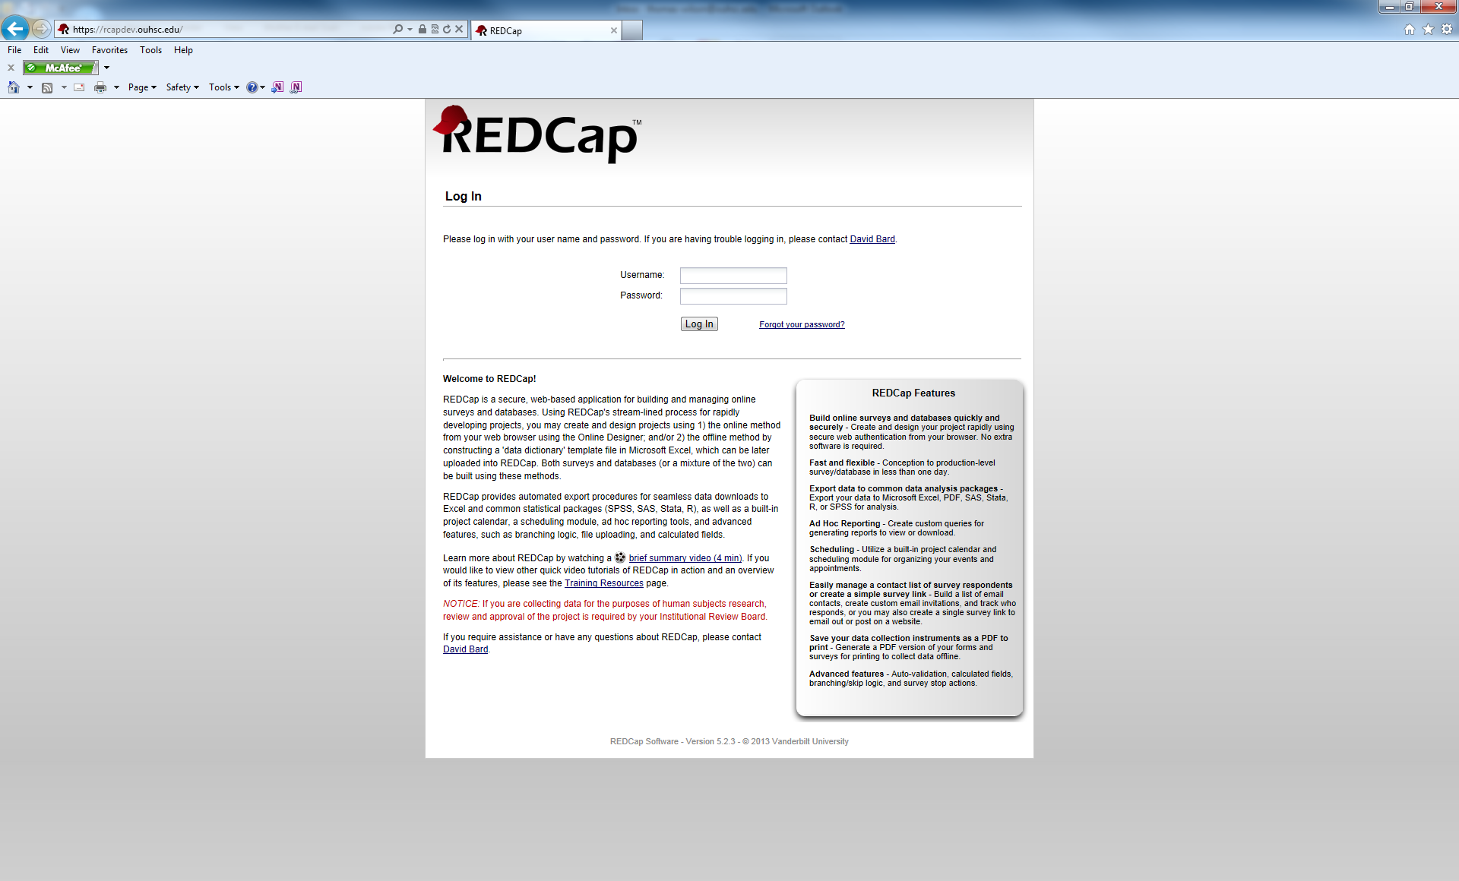

The REDCap username and password are the individual’s OUHSC username and password. When logging in for the first time, users will see a screen to edit their user profile:

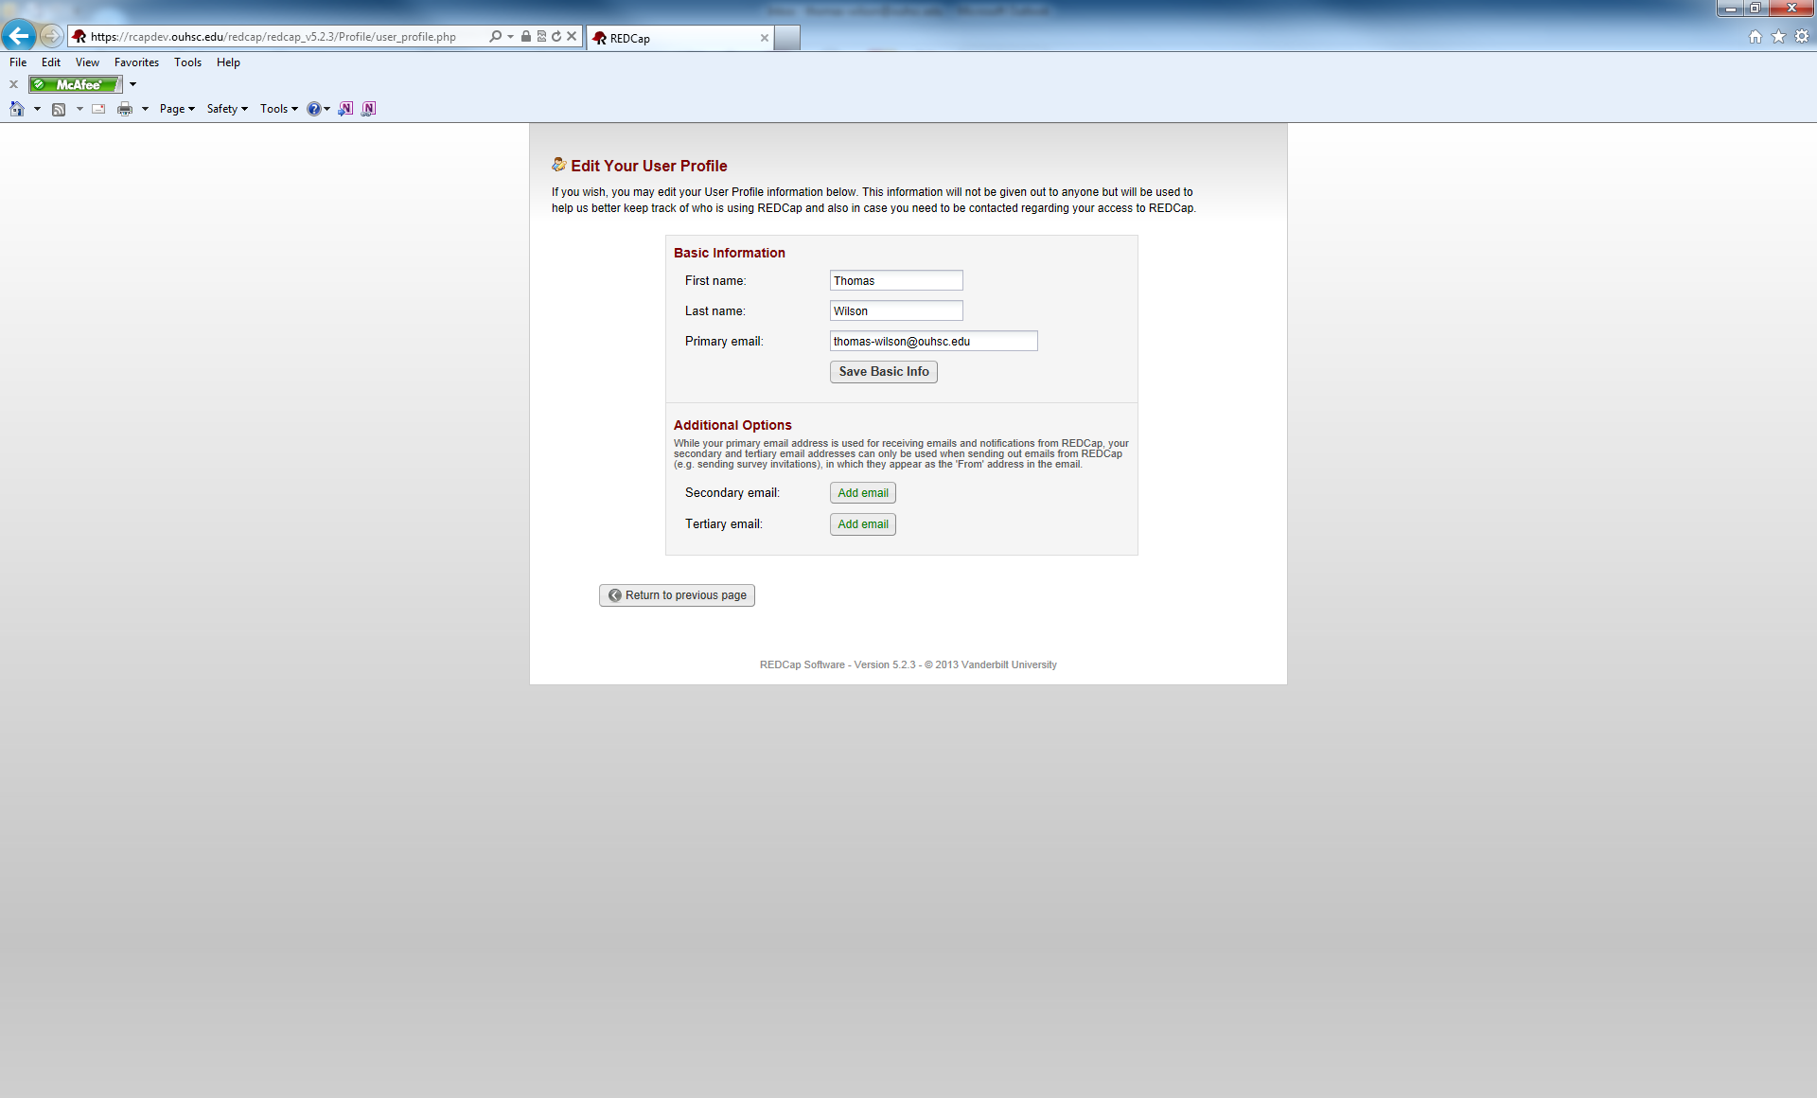

After a user submits their profile information, a profile confirmation link will be e-mailed to them automatically. When the link arrives in the user’s inbox, they can click on the link and they will be ready to login and begin using REDCap.

After logging into REDCap, users will see the menu below:

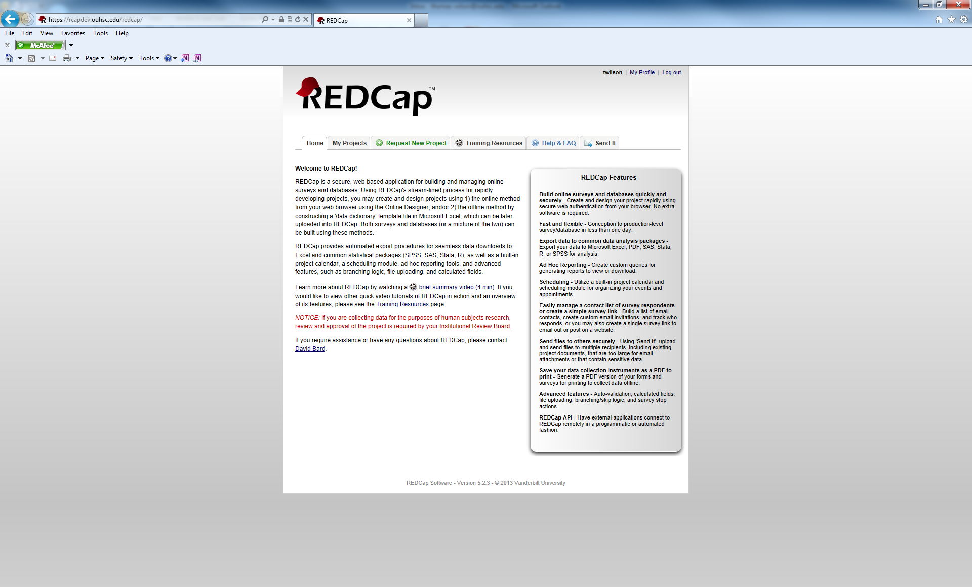

**Navigating the REDCap Menu:**

The REDCap menu has 6 tabs:

**Home:** This tab gives a brief overview of REDCap and it’s features. 

**My Projects:** This tab shows a list of all projects a user has access to view (in this example, the user only has access to the public training projects). This list will vary depending on the user.

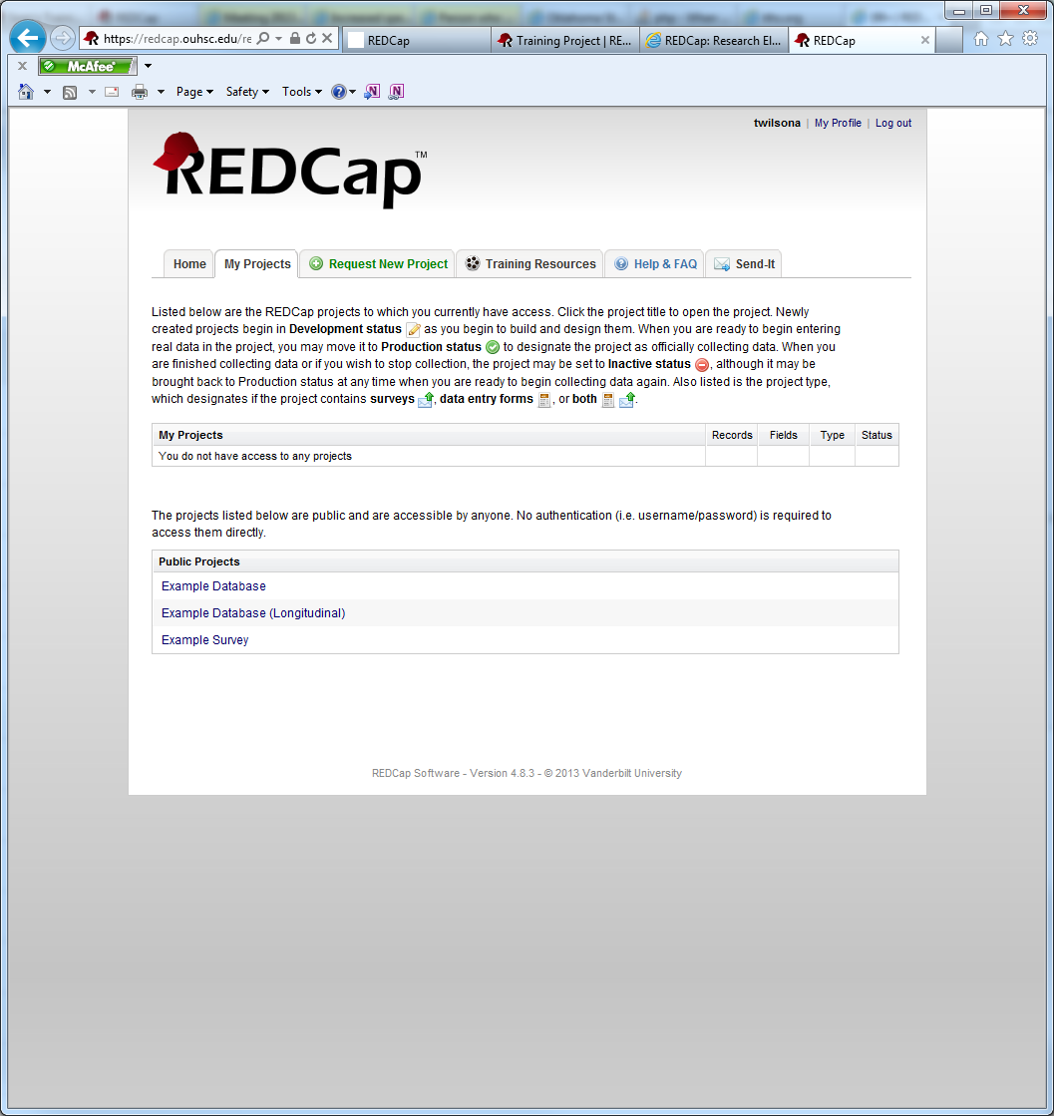

**Request New Project:** This is where a user would request that a new project be created.

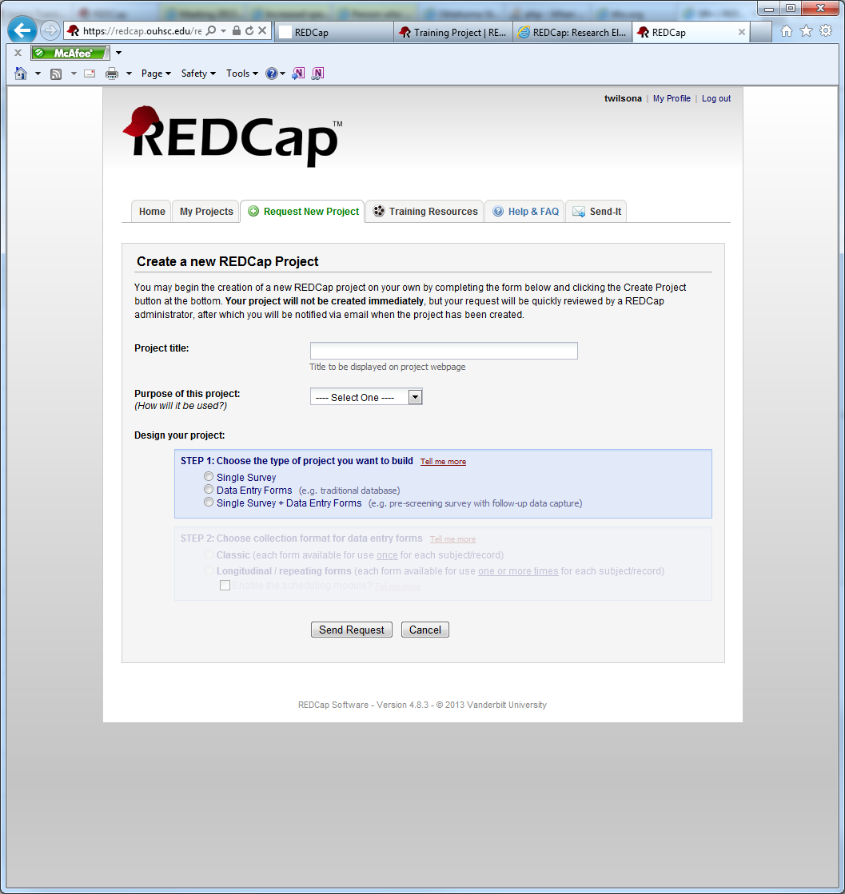

**Training Resources:** This tab is a library of official REDCap training videos and resources.

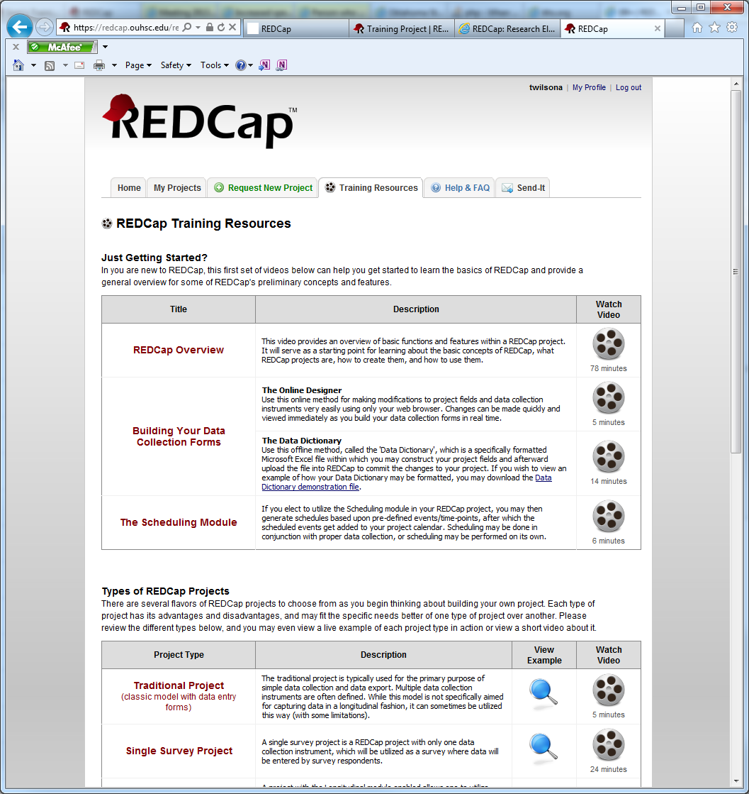

**Help & FAQ:** This tab contains many questions regarding the features and use of REDCap.

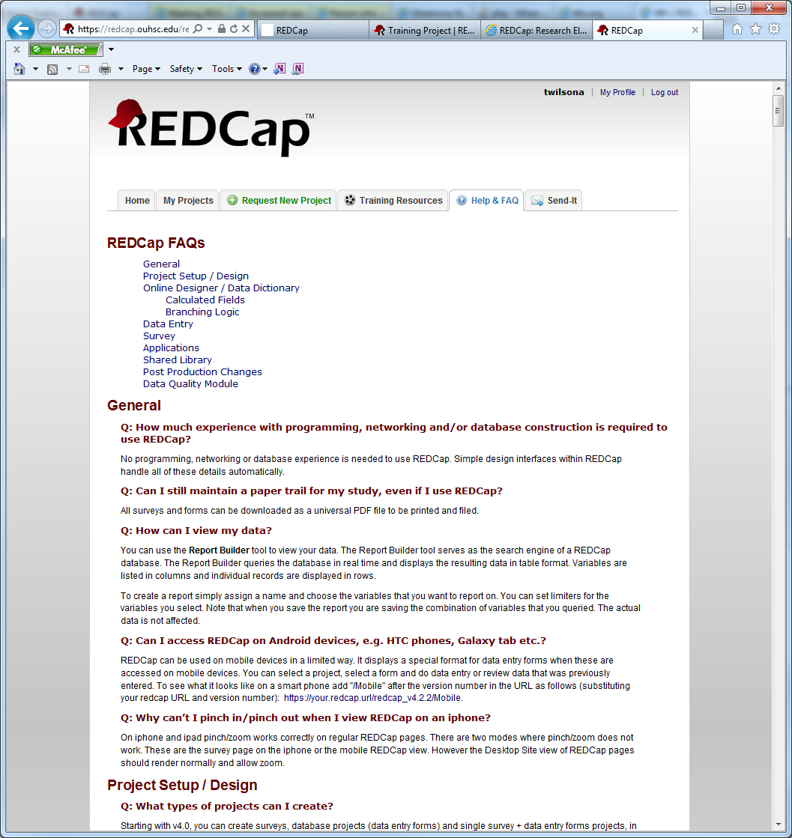

**Send-It:** The send-it tab is a secure data transfer application, that allows users to upload files and then allow multiple recipients to downlaod the file in a secure manner.

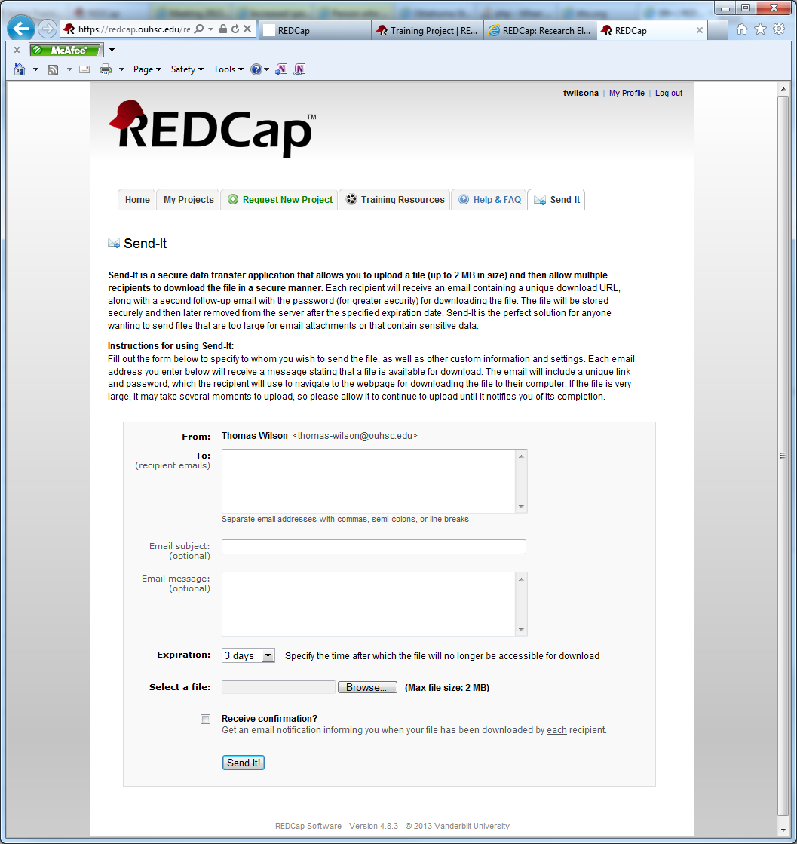

**Navigating the Project Menu:**

A user’s project menu is customized based upon the user right’s that are assigned to them. The project menu shown here is for a data entry user who has minimal rights. For an exhaustive menu, take the 201 course.

The first block of menu items contain the following information:

* Username and link to logout
* My Projects: Returns the user to the main REDCap menu
* Project Home: Links user to the main page for a specific project (the Project Home page is shown below.
* Project Setup: Takes the user to the settings page for this project.

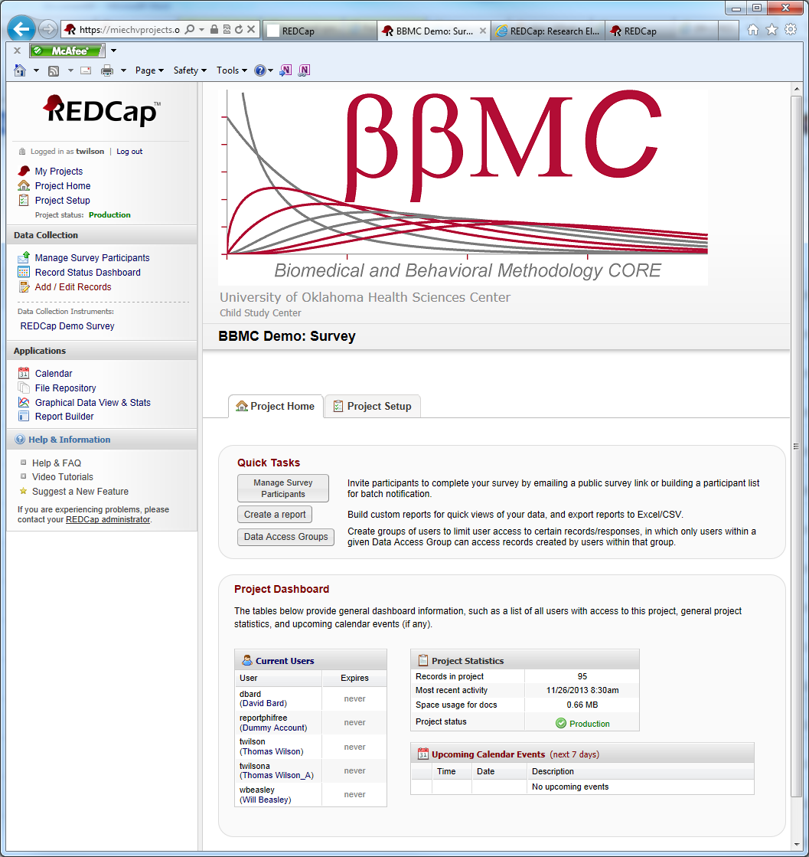

**Data Collection:** This portion of the the REDCap Project Menu contains links for the data collection aspect of a project. Users will utilize these menu options when recording data.

* Manage Survey Participants: This link navigates users to the menu for options on sending surveys to participants.
* Record Status Dashboard: the Dashboard shows the status of all records that have been collected (Complete, Unverified, Incomplete, Completed Survey Response, or Partial Survey Response)
* Add/Edit Records: Use this link to add a new record to the project or to edit responses (must have appropriate permissions to do edit a response)
* Data Collection Instruments: A list of all data collection instruments included in this project. In this example, there is only one data collection instrument named: “REDCap Demo Survey”.



**Applications:** Lists all extra functions that a user can access.

Calendar: This is the REDCap built-in calendar function. You can add appointments, create schedules for participants (if project is longitudinal), etc.

File Repository: The file repository is a place to store important study documents in a centralized location. Examples of documents include: blank consent forms, study fliers for advertisement, study mailers, etc. Do NOT store signed consent forms in this locations.

Graphical View and Stats: Allows a user to create basic univariate bar graphs and pie charts.

Report Builder: Gives users the ability to create simple reports. Examples, include: showing a list of all female participants, sorting all participants alphabetically, etc.



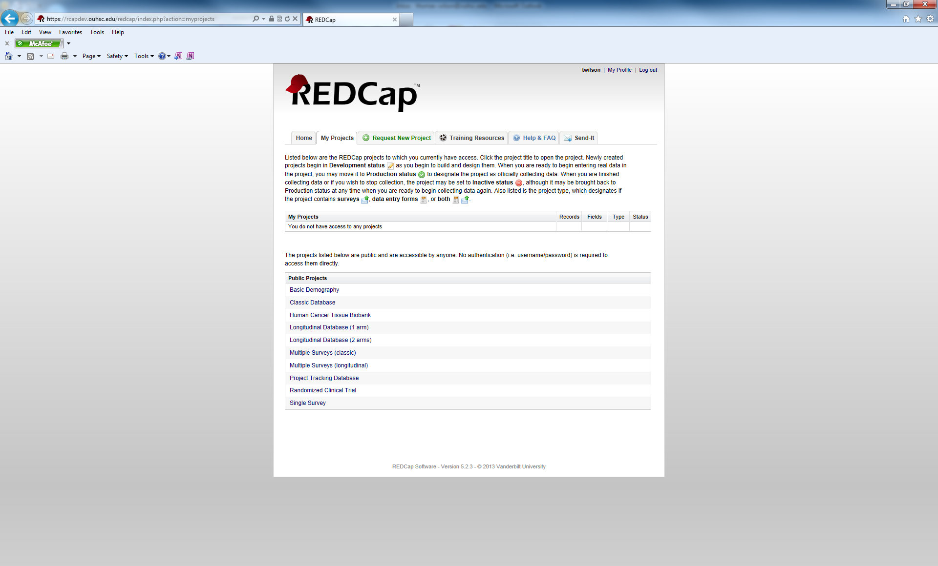

Training Resources Tab

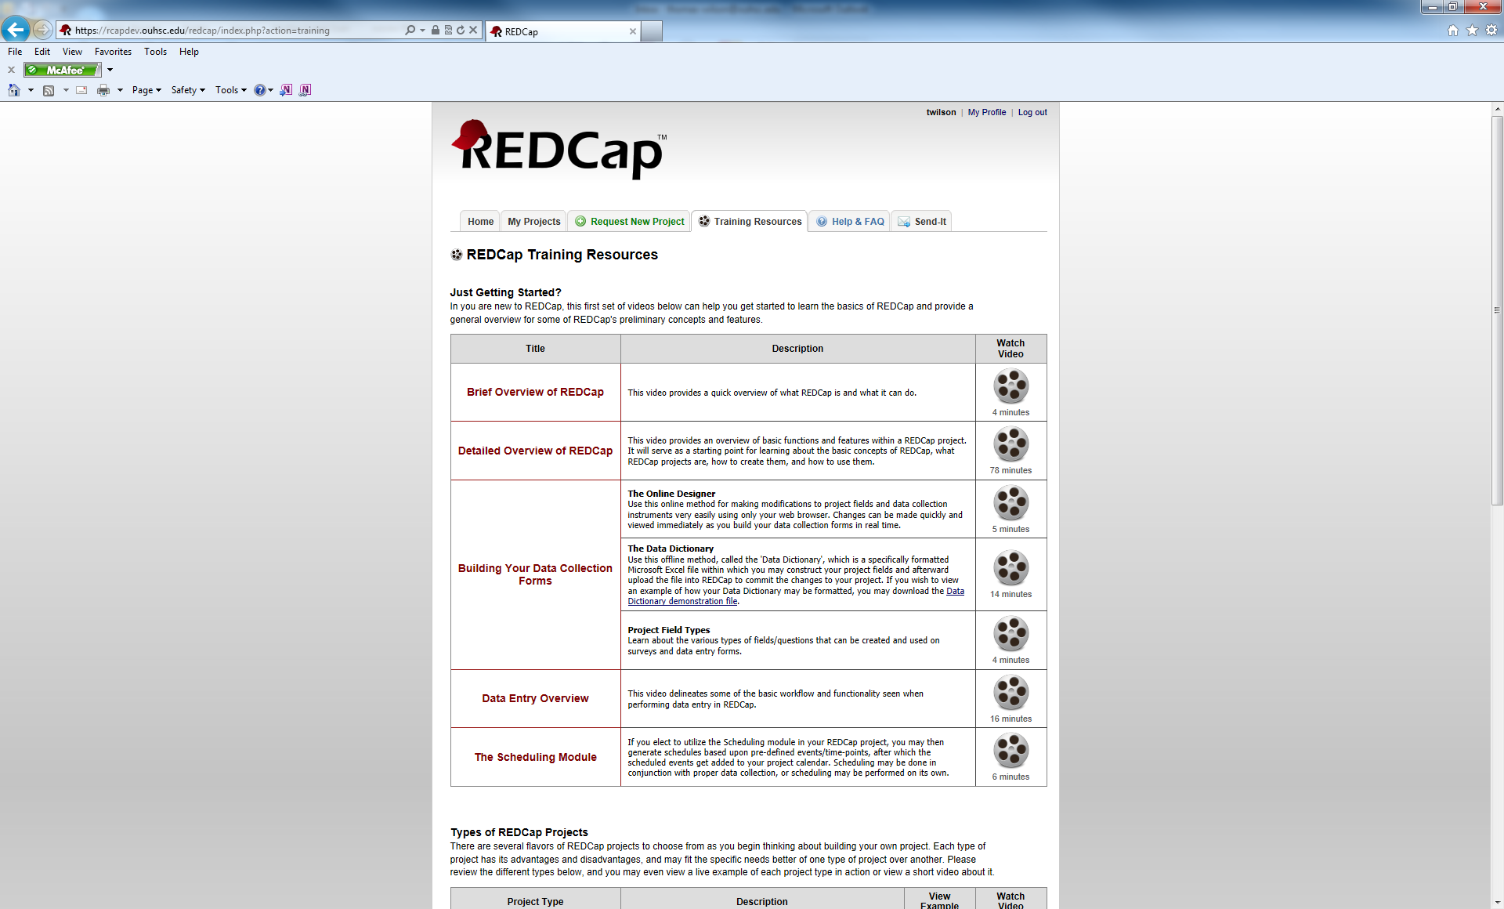

Help and FAQ Tab

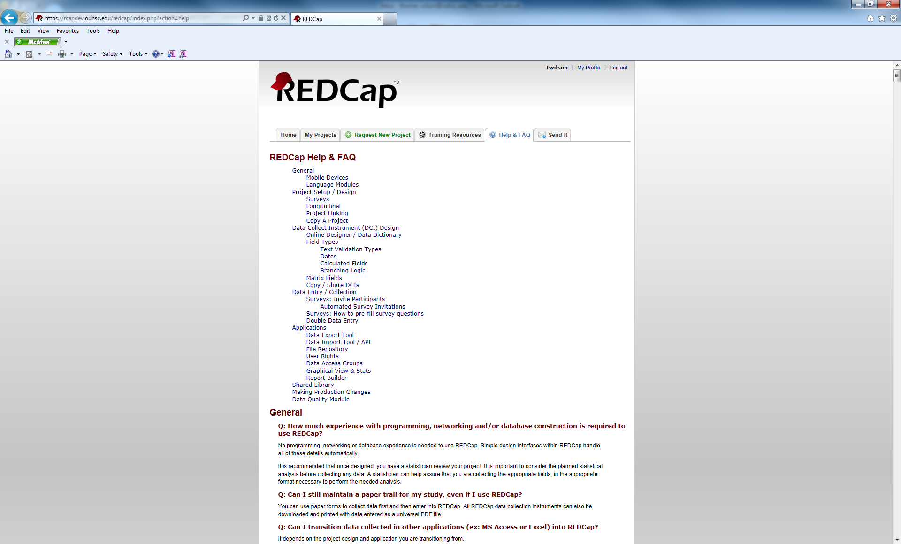

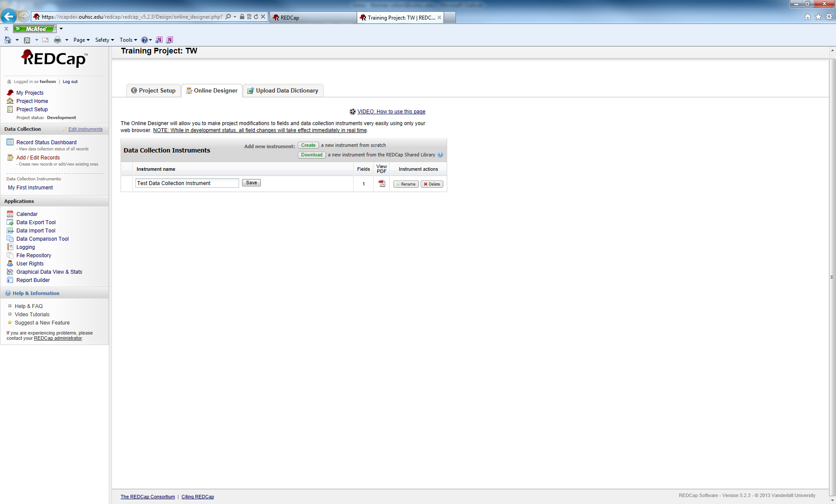

Your DCI has been renamed. Now, we can make modifications.

The nameof the DCI is hyperlinked. Click on the DCI name.

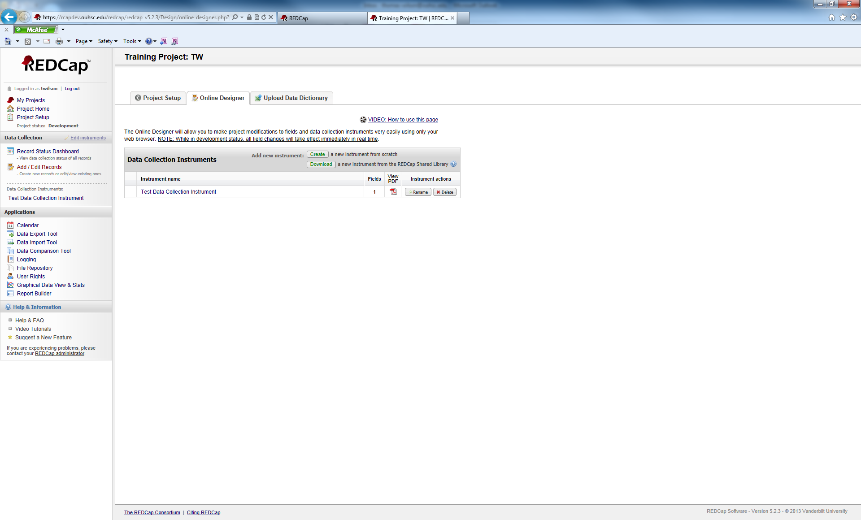

You will see the following screen.

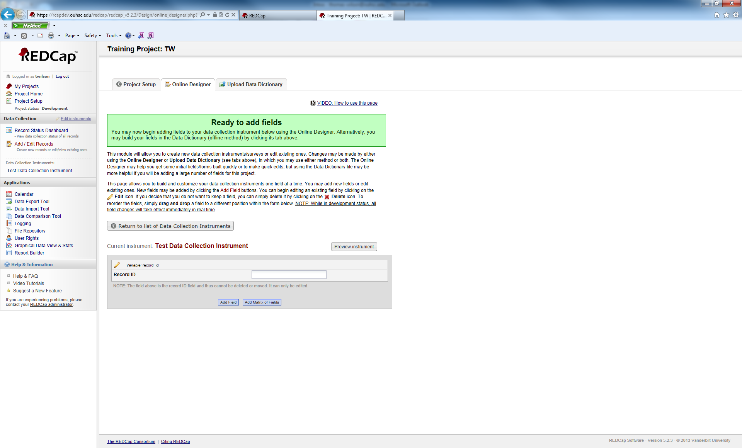

Note, you already have one variable in your DCI. Its field label is Record ID and the actual variable name is record_id. You cannot delete or move this variable. You can change its name. Common options include, participant_id, recruit_id, patient_id, etc.

We are going to add a field. Click on the Add field button.

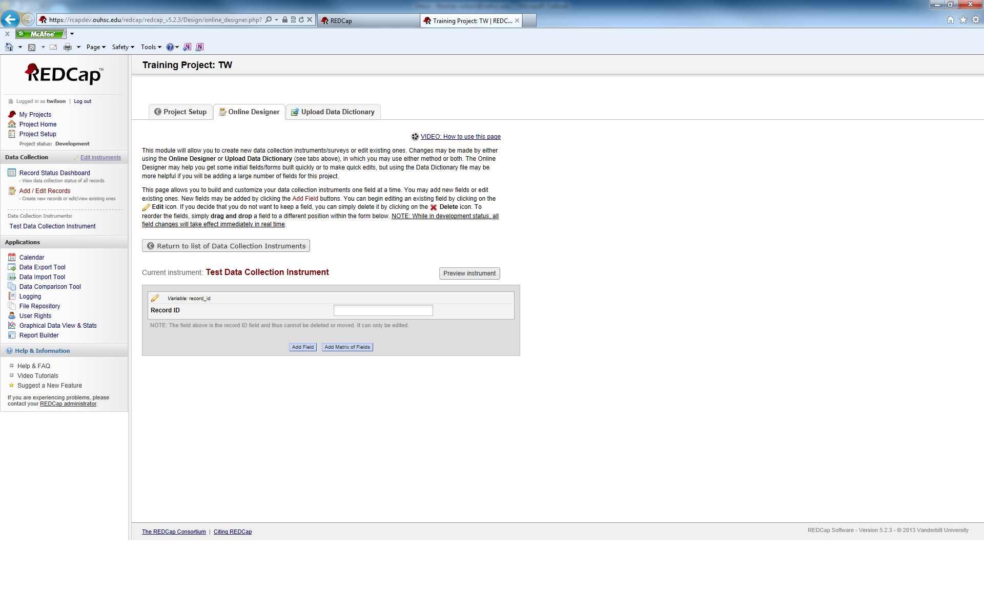

You will see the following pop-up window.

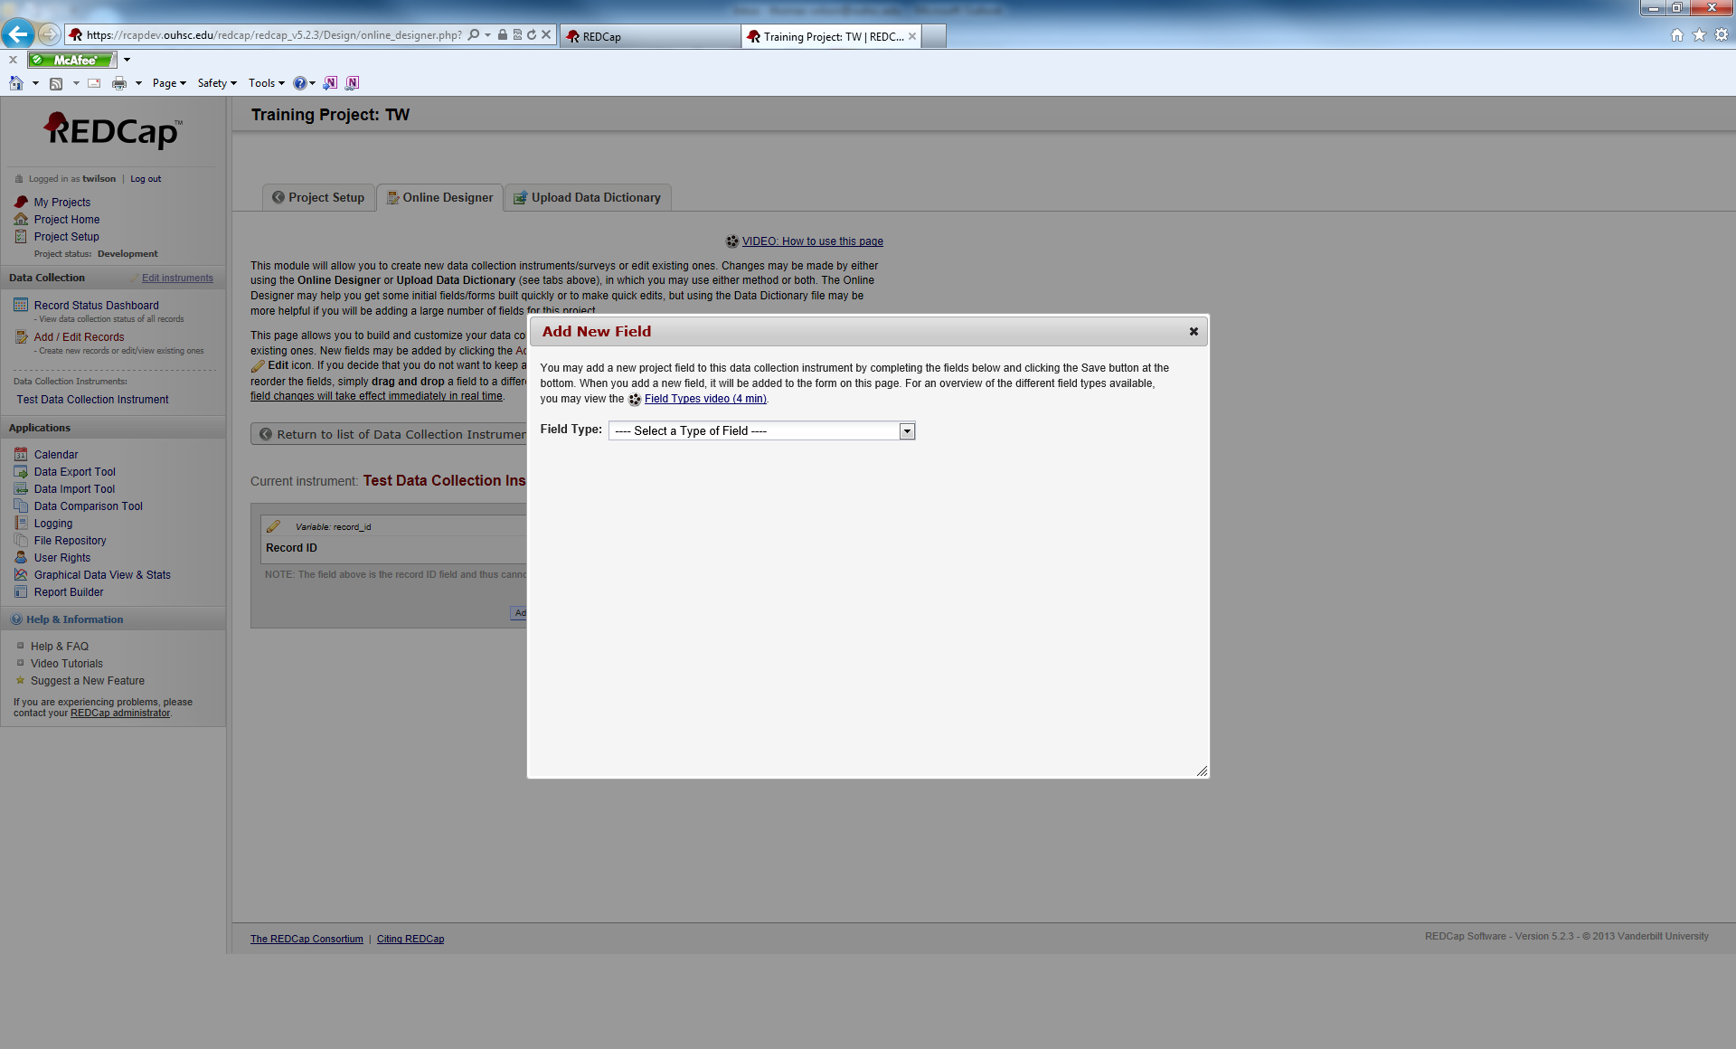

We need to select a Field Type:

Click the arrow for the drop-down menu.



Doing this will reveal all Field Type options.

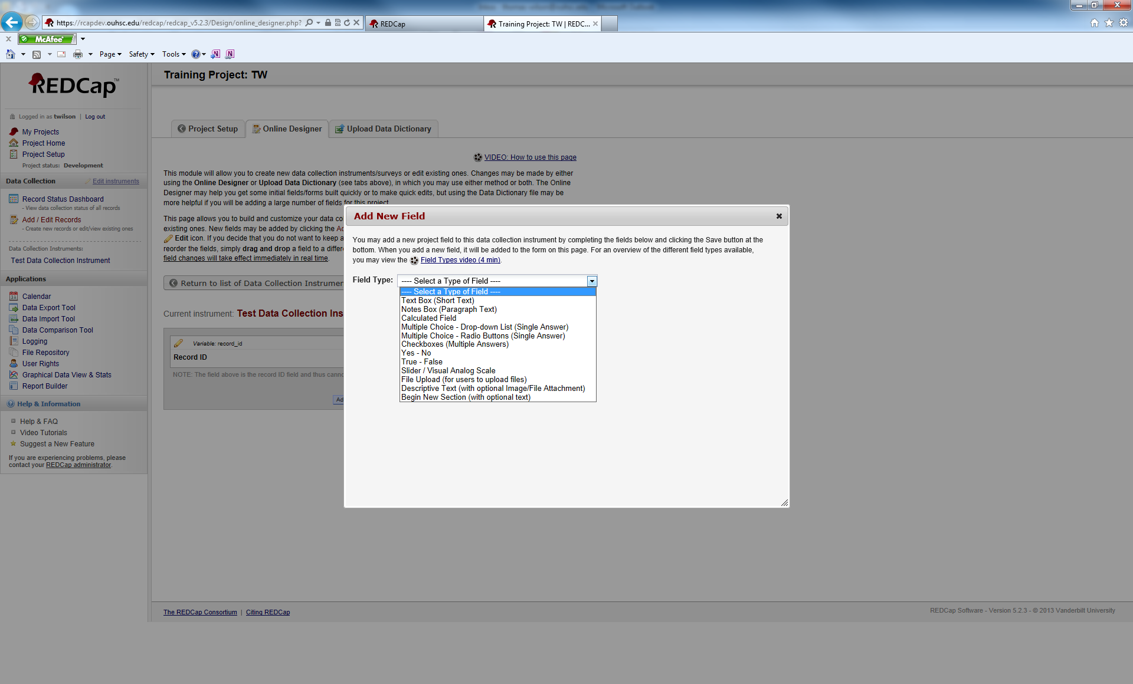

Available Field Types are:

Text Box (Short Text): Use this variable for free response items that have shorter response. Common uses of this variable include: name, address, phone, number, etc.

Notes Box (Paragraph Text): This variable is used for free response items that have a longer response. Response length is virtually unlimited even though the viewing window has a limited size. Common uses of this variable include: Please describe, in detail, any medical problems you are experiencing; Researcher Notes; etc.

Calculated Field: This variable is used to perform calculations on variables. It is limited to calculations on numeric variables only. You can use logical operators. For more information about calculated fields, look at the REDCap FAQ in the main menu screen.

Multiple Choice – Drop-down list (Single Answer): This is for multiple choice items. It creates a drop-down list of available response options. Only one answer can be chosen.

Multiple Choice – Radio Buttons (Single Answer): Similar response type as the drop-down list, except it uses circular buttons that an individual clicks on to select the answer. Again, only one answer can be chosen.

Checkboxes (Multiple Answers): Gives a list of response options. Users are shown square boxes to click in and any number of the response options can be selected. Used in a “Select all that apply” situation.

Yes-No: A multiple choice radio button answer that automically gives you the Yes and No options.

True-False: Same as above, except true/false

Slider/Visual Analog Scale: Creates a clickable sliding scale for users to rate an item from 0 to 100.

File Upload (for users to upload files): Users can upload pertinant documents/files as a response. It can be used to upload documentation (consent forms), scans of x-rays, etc.

Descriptive Text (with optional image/file attachment): This variable does not record any data. It is used as an informative text field to give users warnings, message, or instructions.

Begin New Section (with optional text): Again, this variable does not record any data. It creates a break in between sections in a form. It shows up in a different color.

In our Test Data Collection Instrument, we are going to create one of each type of variable. First we are going to select the Text Box (Short Text) option.

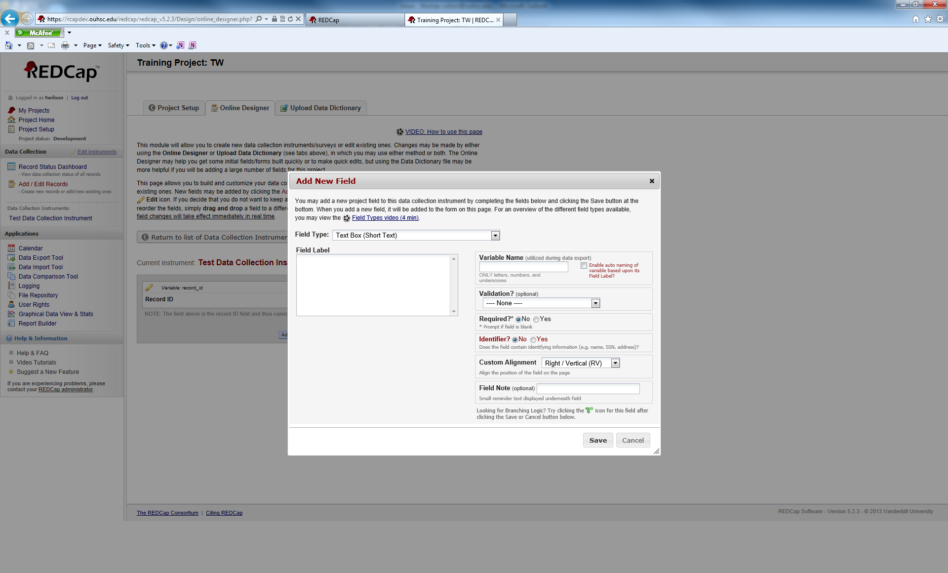

The first box to fill out is the Field Label. The field label is the text that the participant/user will see when working in REDCap.

Enter “Participant First Name” as the field label.

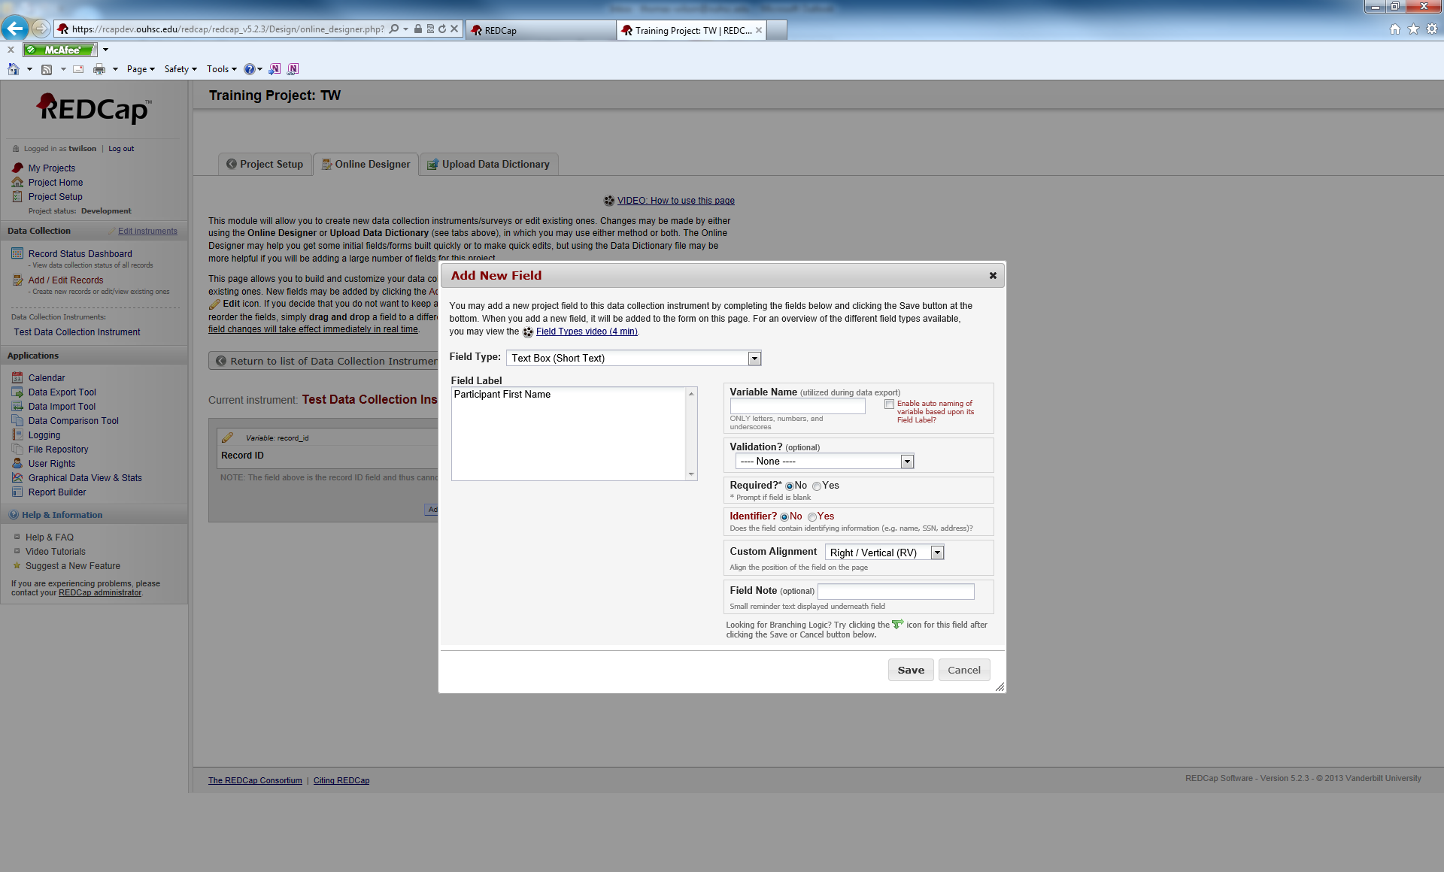

Next, we want to fill in the Variable Name. Underneat the text box for variable name, you will see a warning that says “ONLY letters, numbers, and underscores”. Those are the only characters you can use to name a variable. You may also see a checkbox to the right that says, “Enable auto naming of variable based upon its Field Label?”. If you choose this option, REDCap will automatically name your variables for you. It is convenient, but you have no control over the name. For now, we will leave that option unchecked and name the variables manually.

For the variable name enter, “first_name”.

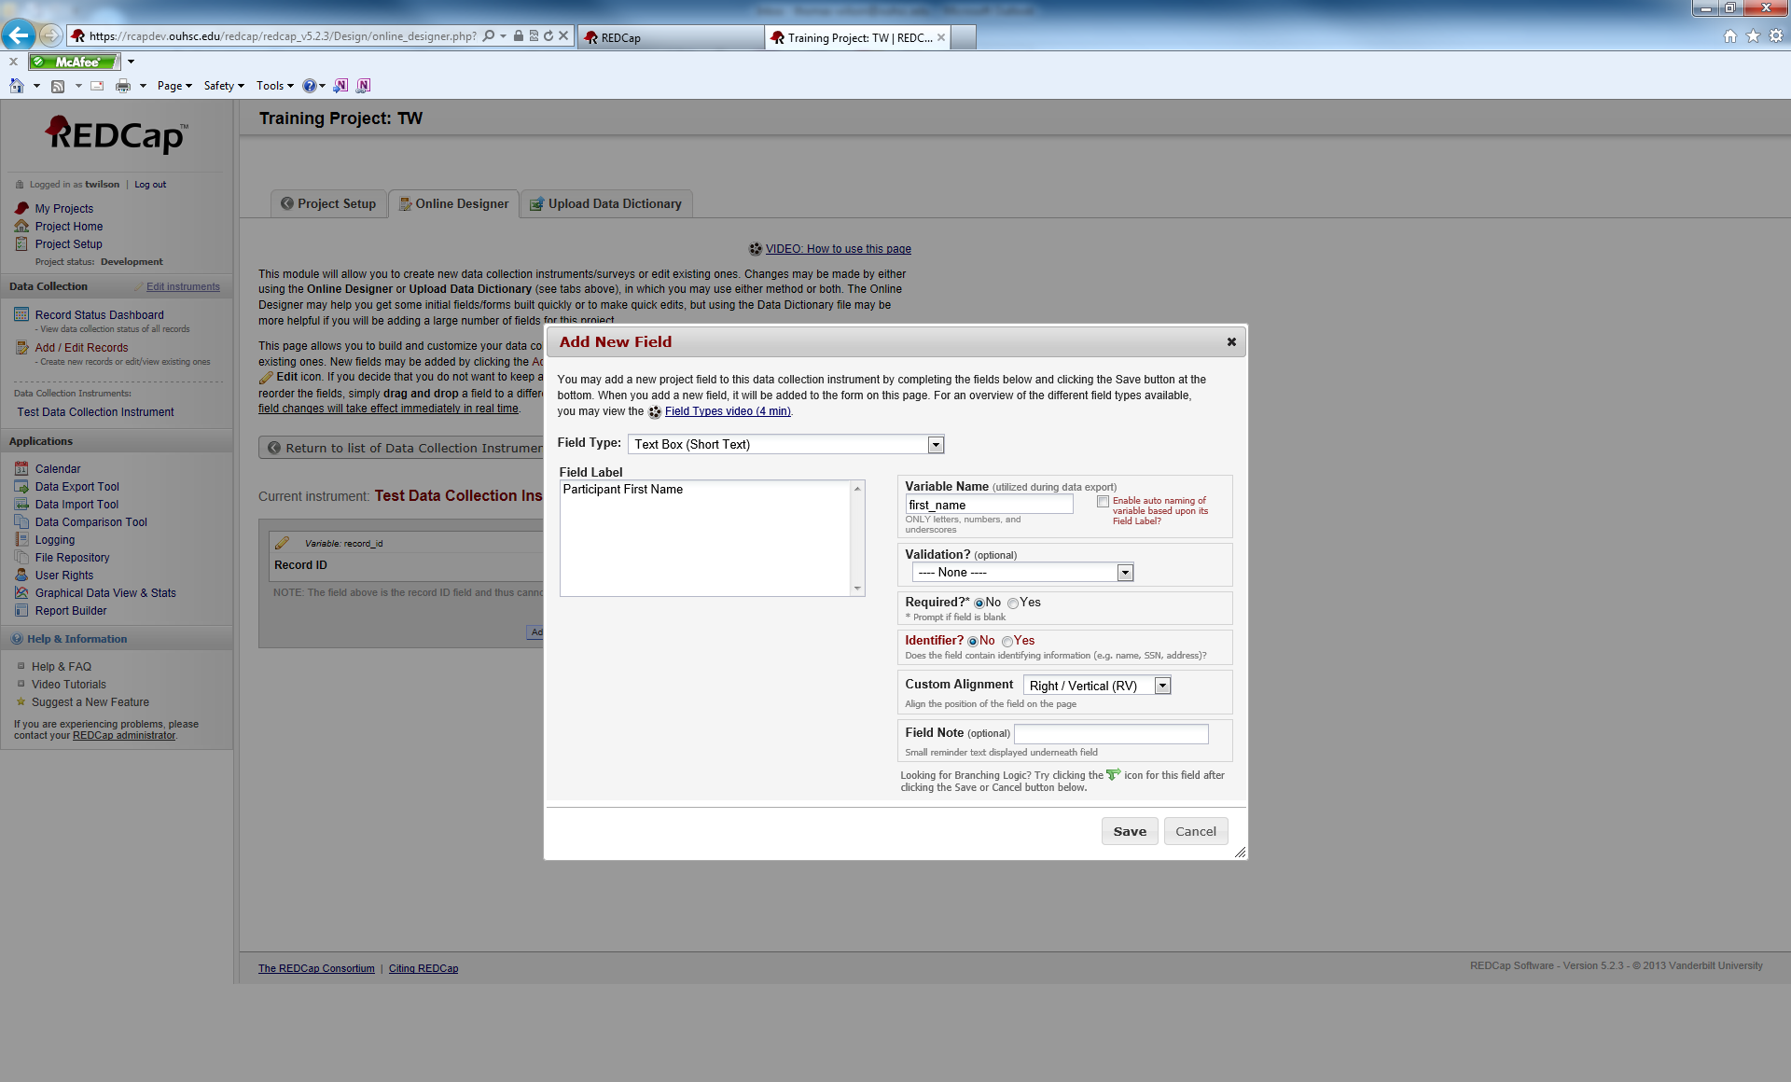

Underneath the variable name, you have an option called Validation?. Validation gives you the following choice:

Date (M-D-Y)

Date (Y-M-D)

Datetime (M-D-Y H:M)

Datetime (Y-M-D H:M)

Datetime w/ seconds (M-D-Y H:M:S)

Datetime w/seconds (Y-M-D H:M:S)

Email

Integer

Number

Phone U.S.

Time (HH:MM)

Zip Code

If you chose any of these options for a variable, the respondent/user will have to enter a value that matches the validation type.

You also have an option to make this a Required response and to mark whether or not the variable is an Identifier.

You have the option for Custom Alignment and adding a field note.

For training purposes, we will not select any of these options. Click save to create our new variable.

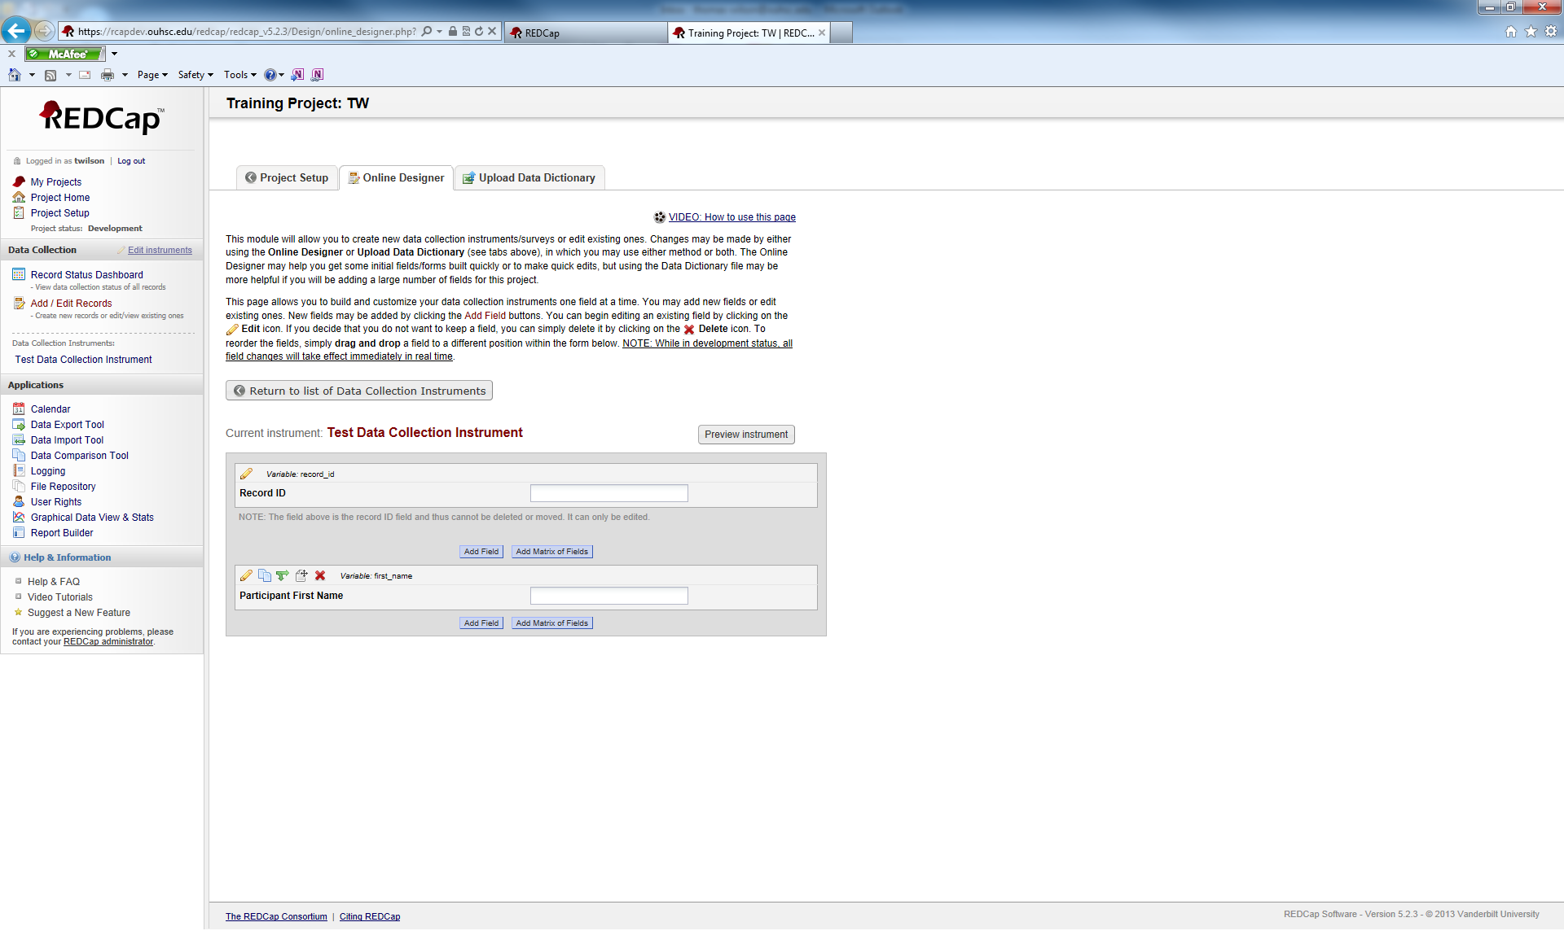

Your new variable will appear directly underneath the previous variable.

**Research Electronic Data Capture**

**REDCap 201**

**Training Manual**

**REDCap Version 5.2.3**

**REDCap Definitions:**

**Arms:**

**Events:**

**Branching Logic:**

**Calendar:**

**Data Dictionary:**

**File Repository:**

**Data Collection Instrument:**

**Project Status:**

**Project Type:**

**Variable Name:**

**Project:** REDcap uses the term project to describe a set of data collection instruments that are store together for the same purpose. An analogous term to use would be a database.

**Survey:** A survey is one of the two types of data collection instruments that REDCap utilizes. You can have multiple surveys within a REDCap project. A REDCap survey can be e-mailed to individual participants where they are given unique “Private Survey URL’s” or a survey can be made public and a “Public Survey URL” can be posted on a website. Private surveys can only be filled out one time whereas, public surveys can be filled out multiple times.

**Form:**  A form is the other type of data collection instrument within REDCap. Its intended use is in a clinical setting where a researcher enters the data into REDCap. Multiple forms can be used in a REDCap project.